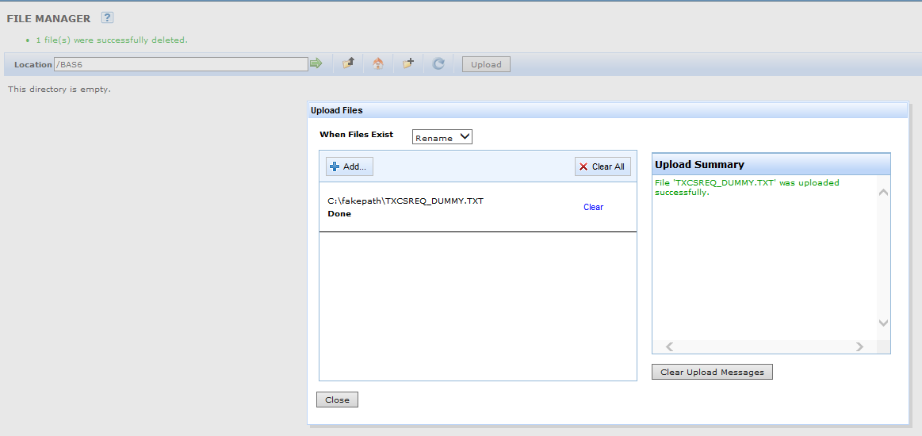
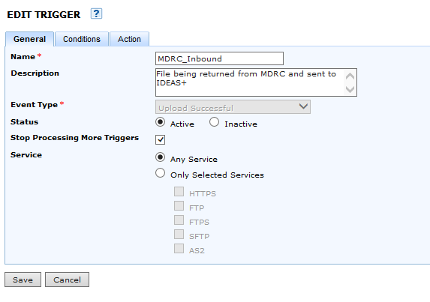
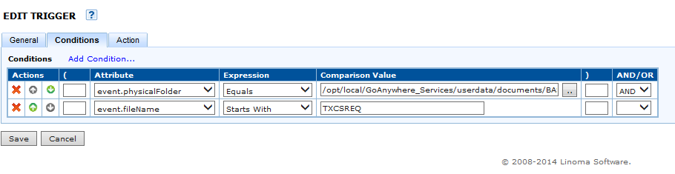
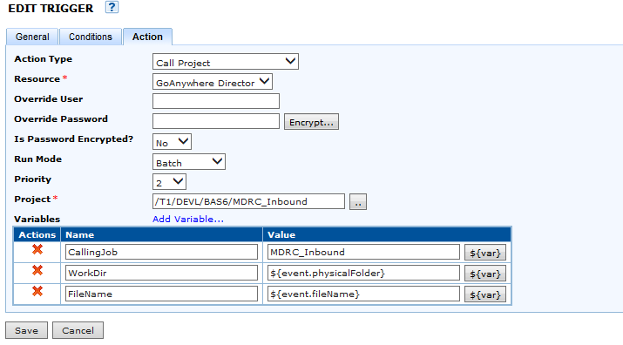
2. Make sure your Trigger is defined and recognizes the file as being Successfully Uploaded
Can’t say I know how to see if the Trigger recognizes the file as being uploaded, although I know it was. And it is listed within the category Upload Successful in Trigger Manager.
Whether or not the project fails, it seems as if the Trigger would call the project. Do I need a userid and password if the

